Directions:
This session will use this word document to demonstrate the accessibility strategies included in the presentation. To practice the tasks below open a blank MS office document and follow along.

Contact Info:
Angela Standridge, M.A, CCC-SLP, ATP (she/her/hers)
Director, Texas Technology Access Program
The Texas Center for Disability Studies
University of Texas at Austin
astandridge@austin.utexas.edu |
Office: (512) 232-0751
Cell: (512) 662-1815
TTAP website

Accessibility Tips: Download this handout at https://utexas.box.com/v/AccessibleMSW

Title a document to facilitate screen and text reading software
  - Click on File above the Ribbon
  - Find Properties>Title
  - Enter a Title
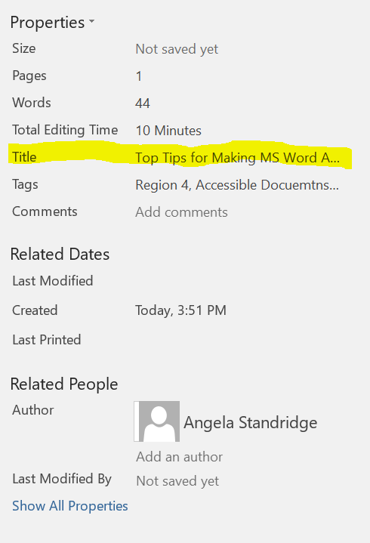

Use Styles for formatting
  - Click on the Styles box in the MS Ribbon. The drop down and pop out arrows will provide more options AND you can create your own styles
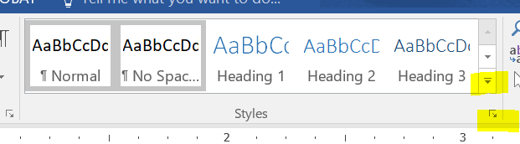
  - This will allow screen/text reading software to work more efficiently. It will also facilitate navigation for people using alternative access tools such as key commands or switch access.

“Save as” .pdf rather than “print to” .pdf
  - If you “print to .pdf, it will strip any formatting (i.e. accessibility functions) you have added into the MS Word document.
  - If you Save As .pdf, it will maintain ant formatting you have added to the MS Word document.
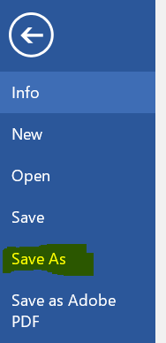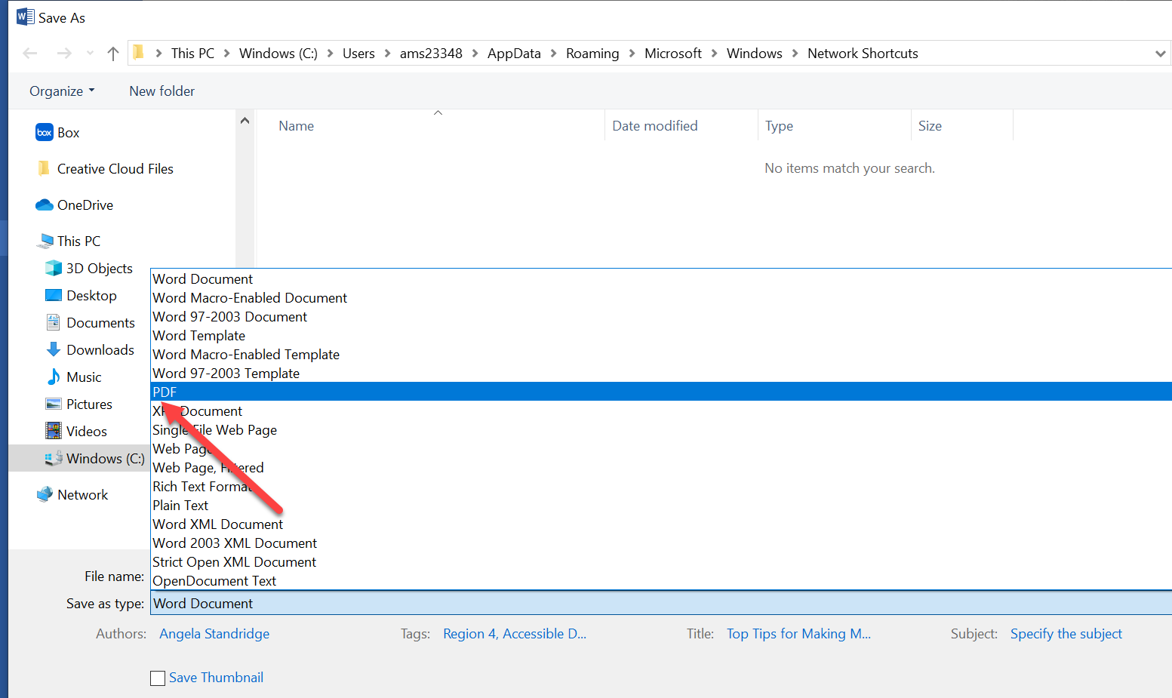

Bookmarks/URL links
  - Do not use the “text” of a full url. This is cumbersome for screen/text readers
    - WRONG: https://disabilitystudies.utexas.edu/
  - Use a summary of site name and add the hyperlink like this:
TX Center for Disability Studies
    - Highlight the summary, right click and select hyperlink
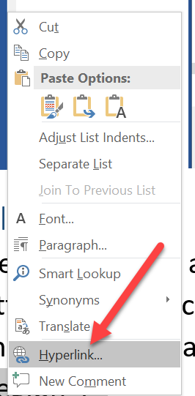
    - OR Click on Insert in the MS Ribbon, highlight the summary, and click hyperlink
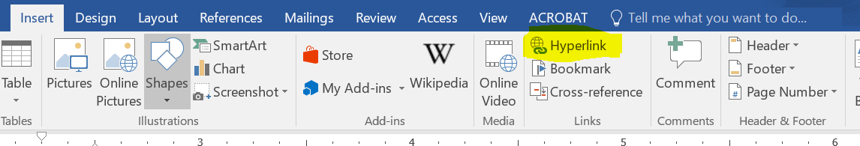
    - Add the full URL and click OK
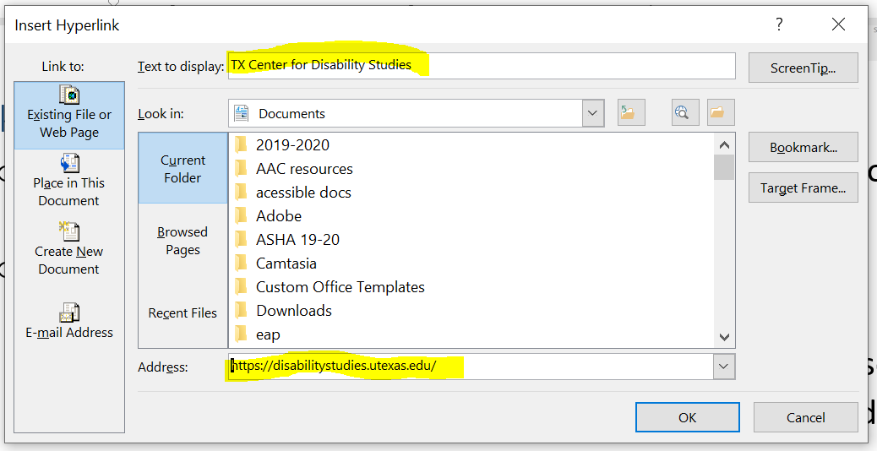
  - If the text of the URL is needed (participants need to type it in from a screen for example), add it in parenthesis without the hyperlink.
    - TX Center for Disability Studies (https://disabilitystudies.utexas.edu)
  - This will allow screen/text reading software to work more efficiently. It will also facilitate navigation for people using alternative access tools such as key commands or switch access.

Tag images
  - Tagging images allows screen reading software to describe graphics to people with visual impairments.
  - The latest versions of MS word will “auto tag”, but often the AI does not really capture the salient meaning, so it is best practice to manually tag, or manually edit the auto tags.
  - Right click on the image
  - Click on format picture
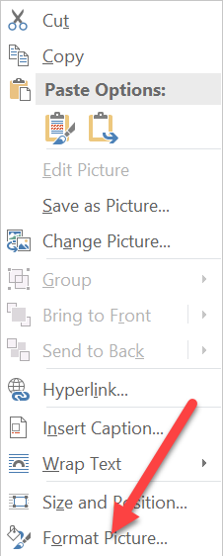
- On the right side of the screen, a Format box will appear
- Click on the Layout and properties icon, and then click Alt Text
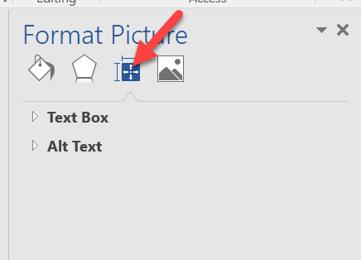
- Add a description that captures the salient intent of the graghic
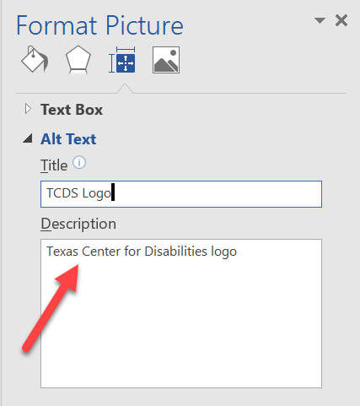

Accessibility Checker
  - Almost all programs have a built in accessibility checker
  - It may in in your Review Ribbon or you may have to add it by editing your Ribbon. You can also add it to your Quick Access Menu at the top.
  - Click on the Accessibility Checker
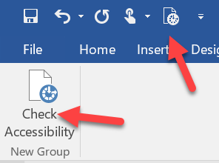
  - A report will be generated and will tell you what elements are not accessible. Click on them to edit them.
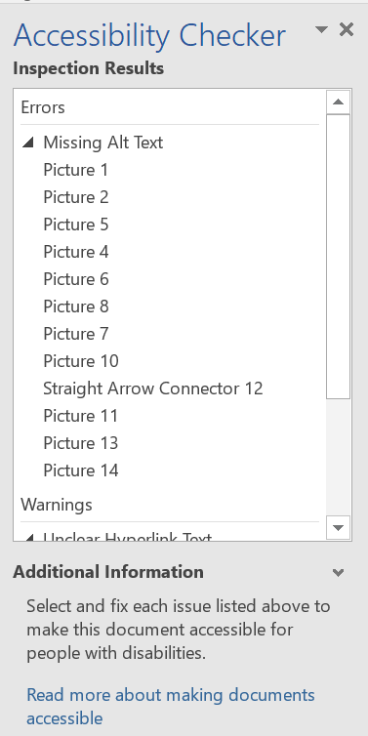

Where can you learn more?
- Accessible Educational Materials
- Assistive Technology 3 ICT Webinars
- Microsoft Accessibility
- Google Accessibility
- Apple Accessibility
- Web Accessibility Initiative W3C
- Webaim
- Section 508

