One Page Description
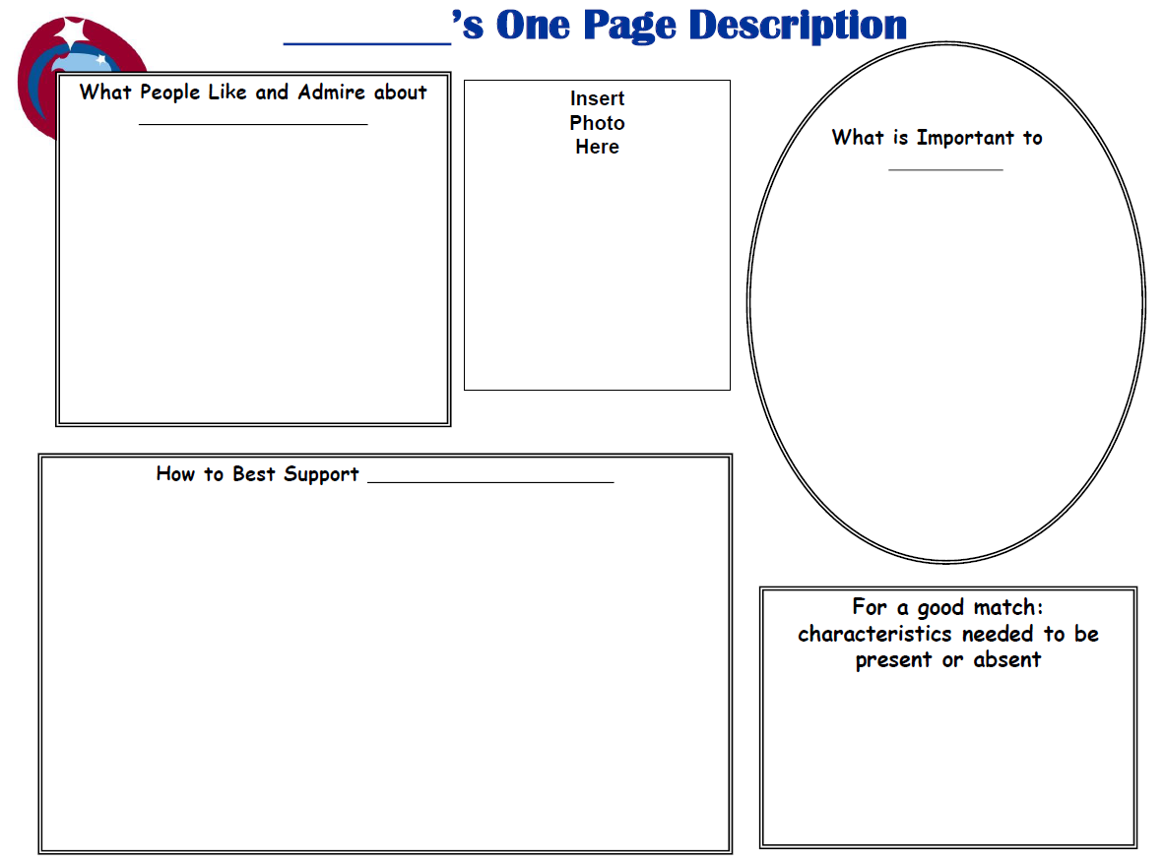

One Page Description For: |  | Add Name Here
What People Like and Admire | Insert Photo Here |  |  | What is Important to
- Add |  |  |  | - Add
How to Best Support |  |  | For a Good Match: Characteristics needed to be present or absent
- Add |  |  | - Add

